FOOD MANAGEMENT SYSTEM

Use-Case Specification: Editing order status

Version <1.0>

Revision History

|  |  |  |  |
| --- | --- | --- | --- |
| **Date** | **Version** | **Description** | **Author** |
| <7/12/2020> | <1.0> | <details> | <Nguyen Thu Trang> |

Table of Contents

1. Use-Case Name 4

1.1 Brief Description 4

2. Flow of Events 4

2.1 Basic flow 4

2.2 Alternative flow 4

2.2.1 <First Alternative flow> 4

2.2.1 <Second Alternative flow> 4

3. Special Requirement 4

3.1 <First Special Requirement> 4

4. Preconditions 4

4.1 <Precondition One> 4

5. Posstcondition 4

5.1 <Postcondition One> 4

6. Extension Points 5

6.1 < Name of Extension Points> 5

Use-Case Specification: Editing order status

1. **Editing order status**
   1. **Brief Description**

This use case defines the step of editing order status**.** The system allow admin to edit information involved to order.

* 1. **Actor**

Customer

1. **Flow of Events**
   1. **Basic Flow**

First, admin click on manage order button. The system display  order view. Admin will update the change off order status (id, name, price, etc). Admin click on Save to confirm change, system will update product information

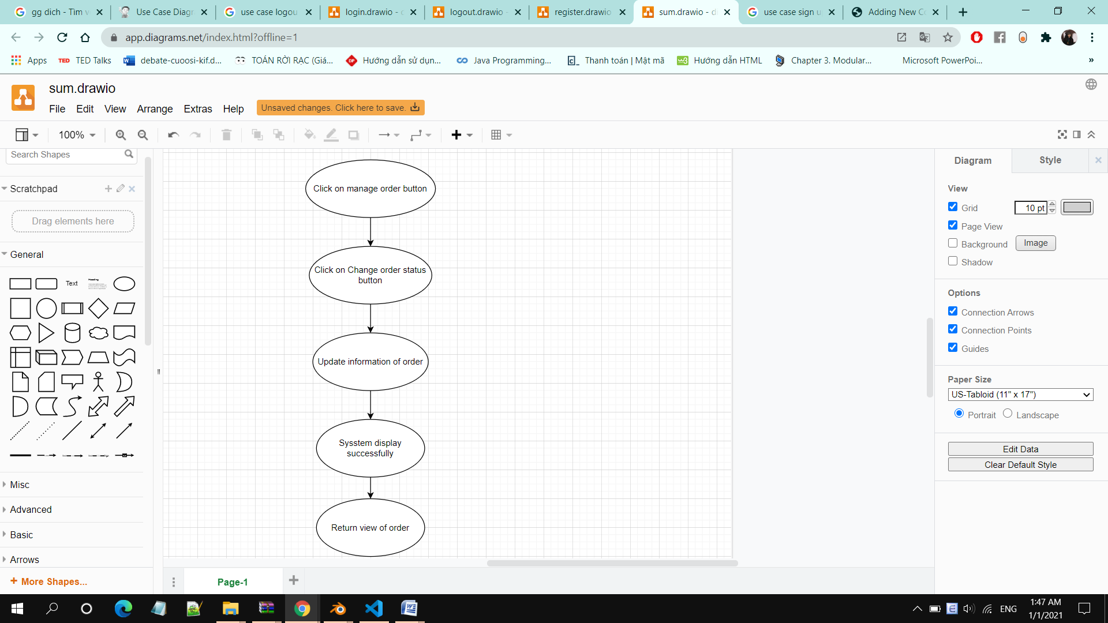

1. **Special Requirements**

Admin must know how to use the product management system.

1. **Preconditions**

Admin has successfully logged in and is in the Ordered View Interface

Admin must have information of the product (Name, Price, image, etc)

1. **Postconditions**

Admin returns to the view of ordered interface

Admin can change the status of the order (cooking, ready)

1. **Extension Points**

No extension points.